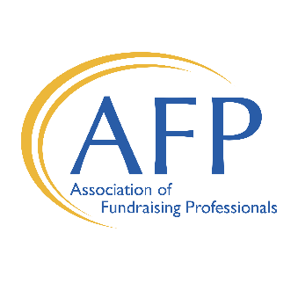

**2024 Nomination Form**

**Outstanding Philanthropist Award:**

This award recognizes an individual or family for contributions to one or more organizations in Northern Illinois. The individual or family must have a proven record of exceptional generosity through direct financial support and demonstrate outstanding civic and charitable responsibility.

**Outstanding Corporation or Foundation:**

Corporations or foundations are honored for outstanding commitment and financial support of philanthropic causes in Northern Illinois. The award recognizes a business or foundation whose generosity has greatly benefited the community, as well as encouraged and motivated others to assume leadership roles toward causes of philanthropy.

**Outstanding Fundraising Volunteer Award:**

This outstanding individual must have demonstrated exceptional leadership skills coordinating major fundraising campaigns and motivating groups of fundraising volunteers for the benefit of charitable institutions.

**Outstanding Community Service Volunteer Award:**

This outstanding individual must have made a significant impact by providing support through gifts of their time and talents to a number of organizations in the not-for-profit community.

**Future Philanthropist Award:**

This award honors an individual or group of young people, up to 24 years of age, for extraordinary volunteer fundraising efforts on behalf of philanthropic causes.

**Presidential Youth Service Award:**

This award recognizes exemplary leadership and generosity of spirit in an elementary, middle or high school student or group of students whose selfless efforts have benefitted a good cause in the community. Young people who receive this award represent the best of humanity and good citizenship and serve as an inspiration to all.

**2024 Nomination Form** *(cont.)*

*AFP Rockford recognizes that* ***we all accomplish more together.*** *If the person or organization you wish to put forward does great work with multiple area nonprofits, please consider working with those organizations to submit a* ***joint nomination****.*

**I am making a nomination for the following award (check one):**

❑ Outstanding Philanthropist (Individual or family)

❑ Outstanding Corporation or Foundation

❑ Outstanding Fundraising Volunteer

❑ Outstanding Community Service Volunteer

❑ Future Philanthropist (Individual or group, must be under the age of 24)

❑ Presidential Youth Service (Individual or group, must be elementary, middle or high school students)

**Nominee:** Name:___________________________________________________________________________ Title:_____________________________________________________________________________ Organization:______________________________________________________________________ Address:_________________________________________________________________________ Phone:_______________________________ Email:______________________________________

**Submitted By:** Name:___________________________________________________________________________ Title:_____________________________________________________________________________ Organization:______________________________________________________________________ Address:_________________________________________________________________________ Phone:_______________________________ Email:______________________________________

Is this a joint nomination? If so, please list partner organizations: ________________________________________________________________________________

**Please address the following in your nomination:**

**1. Based on the award criteria, why should this nominee be honored and recognized?**

**2. List organizations which have benefited from this nominee’s contributions or efforts.**

**3. Attach up to three support letters. These are appreciated but optional.**

Completed nominations may be submitted online at www.afprockford.org or emailed to:

Nicole Riley, Rockford Area Chapter President at [nriley@thesca.org](mailto:nriley@thesca.org)

***All nominations due by Friday, October 11.***